Group 4: Assoc . Prof. Dr. Pelin Özener
Group 5: Asst. Prof. Dr. Nejat N. Çetinkaya
INS3121
January 5th, 2018

SOIL MECHANICS
FINAL EXAM
Q.1/20p | Q.2/20p | Q.3/20p | Q.4/20p | Q.5/20p | TOTAL
Student Name Surname:
Number:
Group:

- a) Mark the correct answers for the following questions.

- Which of the following can exceed %100?
- Degree of Saturation (S) b) water content (w) c) Porosity (n) d) Relative density (D_{r})
- Which of the following term is not used to describe with fine-grained soils?
- Activity b) Plastisity c) Relative density d) Liquidity index
- Which of the following sieve sizes are used to seperate gravel and fine-grained soils?
a) 4 - 40 b) 4-200 c) 40-100 d) 40-200
- Which one of the soil can be used as a subgrade material in a highway construction?
a) CH b) OL c) MH d) SW

- Classify the following inorganic soils by the Unified Soil Classification System (USCS). Which soil given below can be used in a core layer of an earthfill dam? Explain brifiely.

 | Sieve Number | 4 | 10 | 40 | 200 | LL(%) | PL(%) | D₆₀ (mm) | D₃₀  (mm) | D₁₀  (mm)
Soil A | Percent Finer (%) | 84 | 75 | 36.5 | 4 | 41.2 | 23.6 | 0.9 | 0.3 | 0.15
Soil B | Percent Finer (%) | 100 | 100 | 90 | 70 | 72.2 | 41.1 | - | - | -

- a) Calculate the seepage loss under sheet pile per unit width.
b) Calculate the water pressure at point E.
c) Determine maximum water height for not occur a quick condition/sand boiling at the excavation bottom front of the sheet pile.

- A foundation with a dimensions of 12x12m will be constructed on the soil profile in the below figure and the transmitted stress from foundation to ground surface is equal to q=300 kN/m². According to this;
- Calculate the stress increase in the clay layer for the corner points and center of foundation by Boussinesq Method.
- compute the settlement of the foundation due to primary consolidation of the clay layer.(Oturma hesabında a şıkkından elde ettiğiniz ve temel merkezi altı için bulduğunuz Δσ değerini kullanınız. If you couldn’t find the stress increase from part a, assume the stress increase in the middle of the clay layer is equal to Δσ=170 kN/m².)
- Determine the time required for 50% consolidation to take place in the field.

U (%) | 10 | 20 | 30 | 40 | 50 | 60 | 70 | 80 | 90
T_{v} | 0.008 | 0.031 | 0.071 | 0.126 | 0.197 | 0.287 | 0.408 | 0.567 | 0.848
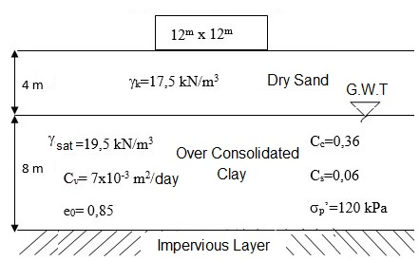

- The results of triaxial tests performed on undisturbed clay soil samples are given in the below table:

Test | Cell Pressure (kPa) | Deviatoric Stress (kPa)
First CD Test | 100 | 150
Second CD Test | 180 | 240
UU Test | 120 | 290

- Compute the drained shear strength parameters of the clay soil from the CD tests.
- Determine whether the soil is normally consolidated or overconsolidated clay
c) Determine the undrained shear strength parameters of the clay soil from the UU test.
d) Plot the Mohr Circle and failure envelope of the clay soil separately from the CD tests and UU test.
e) Which of the shear strength parameters should be used for a temporary (short-term) and long-term condition based on laboratoty test.

- An highway fill will be constructed using sandy clay material. For the soil in borrow area, void ratio, water content and specific gravity of soil solids were given as 1.0, 23% and 2.70, respectively. The results of a Standart Proctor Test conducted on the soil samples are given in the table below.
Wet unit weight (γ_{n}) | 19.5 | 20.4 | 21.3 | 21.9 | 21.5 | 21.0
Water content, w (%) | 12.0 | 12.7 | 13.6 | 15.1 | 16.3 | 17.0

- Plot the compaction curve. Determine the maximum dry unit weight (γ_{kmax}) and optimum moisture content of the soil (w_{opt}).
- Compute the volume of the soil that needs to be excavated from the borrow area to produce 25000 m3…

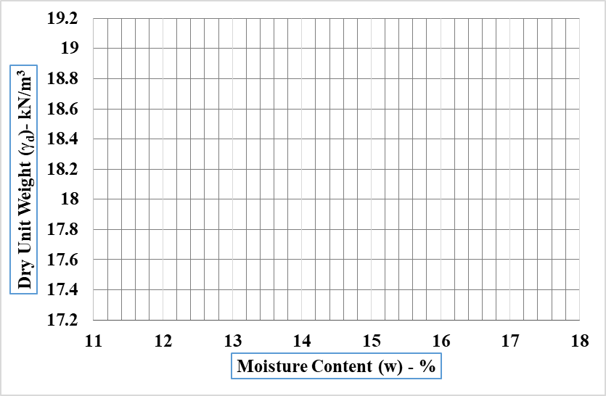

Time is 90 minutes. Good luck…

